GATTINONI ROMA

 |  |  |  |  |  |  |  |  |  | 12319 | 78,09 € | 961.937,10 €
IMAGE | ARTICLE | DESCRIPTION | 35 | 36 | 37 | 38 | 39 | 40 | 41 | QTY | RRP | TOT RRP
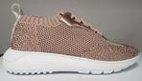 | PENAI1029WKD432 | Aralia Woman Sport Shoe Stretch/Laminated PU Pink/Rose Gold |  | 1 |  | 1 |  |  |  | 2 | 89,90 € | 179,80 €
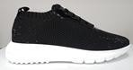 | PENAI1029WKP000 | Aralia Woman Sport Shoe Stretch/Patent PU Black | 2 | 1 | 1 | 4 |  |  |  | 8 | 89,90 € | 719,20 €
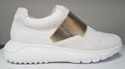 | PENAI1030WFA800 | Aralia Woman Sport Shoe Mesh/Calf PU White |  | 2 | 4 | 9 | 4 | 2 |  | 21 | 79,90 € | 1.677,90 €
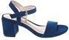 | PENAL0630WMA211 | Woman Sandal Microfiber Dark Blue | 1 | 5 | 3 | 3 | 2 | 2 |  | 16 | 64,90 € | 1.038,40 €
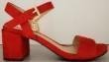 | PENAL0630WMA400 | Woman Sandal Microfiber Red |  |  |  |  |  | 1 |  | 1 | 64,90 € | 64,90 €
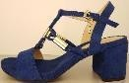 | PENAL0631WMA211 | Woman Sandal Microfiber Dark Blue |  | 1 |  |  |  |  |  | 1 | 69,90 € | 69,90 €
 | PENAL0631WMA302 | Woman Sandal Microfiber Mustard |  | 1 |  |  |  |  |  | 1 | 69,90 € | 69,90 €
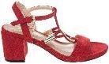 | PENAL0631WMA400 | Woman Sandal Microfiber Red |  | 2 |  |  |  |  |  | 2 | 69,90 € | 139,80 €
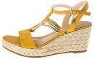 | PENAM0679WMA302 | Woman Shoe Wedge Microfiber Mustard |  |  | 2 |  |  |  |  | 2 | 69,90 € | 139,80 €
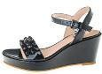 | PENAM0681WPA000 | Woman Shoe Wedge Patent PU Black |  |  |  | 1 |  |  |  | 1 | 69,90 € | 69,90 €
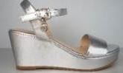 | PENAM0737WLA902 | Woman Shoe Wedge Metallic Silver | 1 |  |  |  |  |  |  | 1 | 69,90 € | 69,90 €
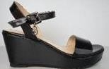 | PENAM0737WPA000 | Woman Shoe Wedge Patent PU Black |  | 2 |  | 1 |  | 1 |  | 4 | 99,90 € | 399,60 €
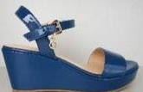 | PENAM0737WPA211 | Woman Shoe Wedge Patent PU Dark Blue |  | 26 | 23 | 31 | 13 | 4 |  | 97 | 99,90 € | 9.690,30 €

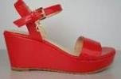 | PENAM0737WPA400 | Woman Shoe Wedge Patent PU Red |  | 27 |  |  |  | 1 |  | 28 | 99,90 € | 2.797,20 €
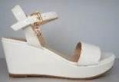 | PENAM0737WPA800 | Woman Shoe Wedge Patent PU White |  | 8 |  |  | 4 | 4 | 2 | 18 | 99,90 € | 1.798,20 €
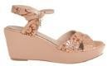 | PENAM0834WPD505 | WOMAN SANDAL Patent PU Embossed Sand |  | 1 | 1 |  |  |  |  | 2 | 69,90 € | 139,80 €
 | PENAM0837WCA400 | WOMAN SANDAL Calf PU Red | 9 | 18 | 26 | 24 | 10 | 8 | 4 | 99 | 74,90 € | 7.415,10 €
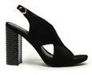 | PENAR0980WMA000 | Aster Woman Sandal Microfiber Black | 1 | 4 | 2 | 3 | 2 | 2 | 2 | 16 | 79,90 € | 1.278,40 €
 | PENAR0980WMA515 | Aster Woman Sandal Microfiber Nude |  | 2 | 1 | 1 | 2 | 1 |  | 7 | 79,90 € | 559,30 €
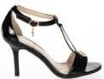 | PENAU0320WPA000 | Woman Shoe Sandal Patent PU Black |  |  |  |  | 2 |  |  | 2 | 69,90 € | 139,80 €
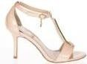 | PENAU0320WPA424 | Woman Shoe Sandal Patent PU Light Rose |  |  |  | 1 | 1 |  |  | 2 | 69,90 € | 139,80 €
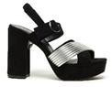 | PENBM0995WKS022 | Bluma Woman Sandal Platea Laminated PU/Microfiber Black/Silver | 4 | 11 | 17 | 18 | 14 | 7 | 1 | 72 | 85,90 € | 6.184,80 €
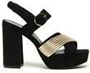 | PENBM0995WKS048 | Bluma Woman Sandal Platea Laminated PU/Microfiber Black/Lt Gold |  | 2 | 2 | 3 | 2 | 1 |  | 10 | 85,90 € | 859,00 €
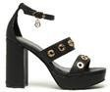 | PENBM0996WCA000 | Bluma Woman Sandal Platea Calf PU Black | 1 | 2 | 2 | 4 | 3 | 2 | 1 | 15 | 89,90 € | 1.348,50 €
 | PENBM0996WCA800 | Bluma Woman Sandal Platea Calf PU White | 4 | 13 | 17 | 20 | 14 | 7 |  | 75 | 89,90 € | 6.742,50 €
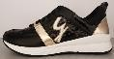 | PENBR0727WGL020 | Woman Sport Shoe Glitter Black/Gold |  |  |  |  | 1 |  |  | 1 | 69,90 € | 69,90 €
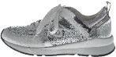 | PENBR0727WGL913 | Woman Sport Shoe Glitter Silver/Pewter |  |  |  |  | 1 |  |  | 1 | 69,90 € | 69,90 €
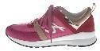 | PENBR0727WIM601 | Woman Sport Shoe Nylon/Microfiber Fuchsia |  |  |  |  | 1 | 1 |  | 2 | 69,90 € | 139,80 €

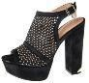 | PENCC0664WNA000 | Woman Sandal Nubuck PU Black |  | 1 |  |  | 1 |  |  | 2 | 79,90 € | 159,80 €
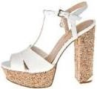 | PENCC0668WCA802 | Woman Sandal Calf PU Off White |  |  |  |  |  | 1 |  | 1 | 74,90 € | 74,90 €
 | PENCC0842WCA000 | Woman Sandal Calf PU Black | 4 | 14 | 15 | 10 |  | 2 |  | 45 | 74,90 € | 3.370,50 €
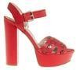 | PENCC0842WCA400 | WOMAN SANDAL Calf PU Red | 5 | 10 | 12 | 9 |  |  |  | 36 | 74,90 € | 2.696,40 €
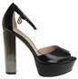 | PENCC0844WLL000 | WOMAN SANDAL Laminated PU Black |  |  |  | 1 |  |  |  | 1 | 74,90 € | 74,90 €
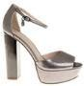 | PENCC0844WLL105 | WOMAN SANDAL Laminated PU Pewter |  |  | 1 |  |  |  |  | 1 | 74,90 € | 74,90 €
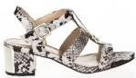 | PENCL0228WBA106 | Woman Sandal Printed Calf PU Stone |  |  | 1 |  |  |  |  | 1 | 69,90 € | 69,90 €
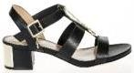 | PENCL0228WCA000 | Woman Sandal Calf PU Black |  | 1 |  |  |  | 1 |  | 2 | 69,90 € | 139,80 €
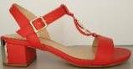 | PENCL0622WCA400 | WOMAN SANDAL Calf PU Red | 1 |  |  |  |  |  |  | 1 | 69,90 € | 69,90 €
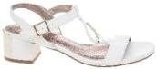 | PENCL0622WCA800 | WOMAN SANDAL Calf PU White |  | 1 |  |  |  |  |  | 1 | 69,90 € | 69,90 €
 | PENCL0830WCA000 | Woman Sandal Calf PU Black |  | 3 | 12 | 12 | 8 |  |  | 35 | 69,90 € | 2.446,50 €
 | PENCL0830WCA800 | WOMAN SANDAL Calf PU White |  |  |  |  | 1 |  |  | 1 | 69,90 € | 69,90 €
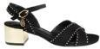 | PENCL0830WMA000 | Woman Sandal Microfiber Black |  |  | 1 |  |  |  |  | 1 | 74,90 € | 74,90 €
 | PENCL0832WCA000 | Woman Sandal Calf PU Black |  | 6 |  | 6 | 1 | 2 |  | 15 | 69,90 € | 1.048,50 €
 | PENCL0832WCA418 | WOMAN SANDAL Calf PU Powder | 3 | 8 | 19 | 17 | 9 | 3 |  | 59 | 69,90 € | 4.124,10 €
 | PENCL0832WMA000 | Woman Sandal Microfiber Black |  |  |  |  | 3 | 1 | 2 | 6 | 74,90 € | 449,40 €
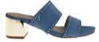 | PENCL0832WMA214 | WOMAN SANDAL Microfiber Denim |  |  |  | 1 | 1 | 2 | 1 | 5 | 74,90 € | 374,50 €

 | PENCL0832WMA300 | WOMAN SANDAL Microfiber Yellow | 1 | 4 | 4 | 4 | 3 | 1 |  | 17 | 74,90 € | 1.273,30 €
 | PENCL0832WPD000 | WOMAN SANDAL Patent PU Embossed Black | 1 |  |  |  |  |  |  | 1 | 69,90 € | 69,90 €
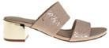 | PENCL0832WPD505 | WOMAN SANDAL Patent PU Embossed Sand |  | 14 | 10 | 13 | 9 | 8 | 1 | 55 | 69,90 € | 3.844,50 €
 | PENCL0833WMA000 | Woman Sandal Microfiber Black |  | 19 | 15 | 26 | 42 | 14 | 16 | 132 | 74,90 € | 9.886,80 €
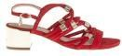 | PENCL0833WMA400 | Woman Sandal Microfiber Red | 1 | 28 | 63 | 56 | 59 | 26 |  | 233 | 74,90 € | 17.451,70 €
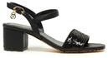 | PENCL0976WCC000 | Clio Woman Sandal Calf PU/ Paillettes Black |  | 1 | 2 | 2 | 2 | 1 |  | 8 | 69,90 € | 559,20 €
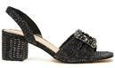 | PENCL0979WTX000 | Clio Woman Sandal Lurex Black |  |  | 1 |  | 1 | 1 |  | 3 | 79,90 € | 239,70 €
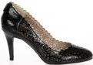 | PENCN0294WPA000 | Woman Shoe Décolleté Patent PU Black | 5 | 15 | 18 | 13 | 14 | 12 | 5 | 82 | 69,90 € | 5.731,80 €
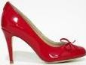 | PENCN0297WPA400 | Woman Shoe Décolleté Patent PU Red | 2 | 4 | 2 | 6 | 2 | 8 | 1 | 25 | 64,90 € | 1.622,50 €
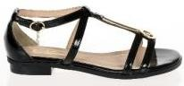 | PENCO0311WPA000 | Woman Flat Sandal Patent PU Black |  |  |  |  |  | 1 |  | 1 | 49,90 € | 49,90 €
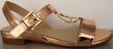 | PENCR0619WLA900 | Woman Flat Sandal Metallic Gold |  | 1 |  |  |  | 1 |  | 2 | 54,90 € | 109,80 €
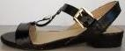 | PENCR0619WPA000 | Woman Flat Sandal Patent PU Black |  | 1 |  |  | 1 |  |  | 2 | 54,90 € | 109,80 €
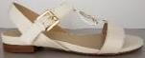 | PENCR0619WPA800 | Woman Flat Sandal Patent PU White | 1 |  | 1 |  | 1 |  |  | 3 | 54,90 € | 164,70 €
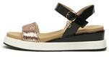 | PENCV0997WPL046 | Clivia Woman Sandal Patent PU/Paillettes Black/Rose Gold |  |  |  |  |  |  | 1 | 1 | 79,90 € | 79,90 €
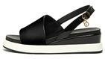 | PENCV0998WCA000 | Clivia Woman Sandal Calf PU Black |  | 1 |  |  | 2 |  | 1 | 4 | 79,90 € | 319,60 €
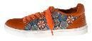 | PENCY0720WCB301 | Woman Sport Shoe Calf PU/ Ptd Calf PU Orange | 6 | 9 | 21 | 9 | 2 | 1 |  | 48 | 64,90 € | 3.115,20 €

 | PENCY0720WCM800 | Woman Sport Shoe Calf PU/Microfiber White | 2 | 11 | 11 | 12 | 8 | 1 |  | 45 | 64,90 € | 2.920,50 €
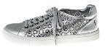 | PENCY0720WLA902 | Woman Sport Shoe Metallic Silver | 2 | 2 | 3 | 2 | 2 |  |  | 11 | 64,90 € | 713,90 €
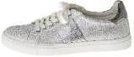 | PENCY0723WBT800 | Woman Sport Shoe Calf PU/Fabric White |  |  |  | 1 | 1 |  |  | 2 | 64,90 € | 129,80 €
 | PENCY0723WCT810 | Woman Sport Shoe Calf PU/ Fabric White/Blue |  |  |  | 1 |  | 1 | 1 | 3 | 64,90 € | 194,70 €
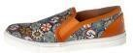 | PENCY0725WCB301 | Woman Sport Shoe Calf PU/ Ptd Calf PU Orange | 5 | 16 | 20 | 26 | 20 | 6 | 1 | 94 | 64,90 € | 6.100,60 €
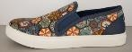 | PENCY0725WCBM14 | Woman Sport Shoe Calf PU/ Ptd Calf PU Multi/Navy | 2 | 3 | 4 | 4 |  |  |  | 13 | 64,90 € | 843,70 €
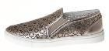 | PENCY0725WLA422 | Woman Sport Shoe Metallic Rose | 1 | 14 | 36 | 24 | 29 | 20 | 8 | 132 | 64,90 € | 8.566,80 €
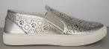 | PENCY0725WLA902 | Woman Sport Shoe Metallic Silver | 6 | 6 | 10 | 3 | 6 |  |  | 31 | 64,90 € | 2.011,90 €
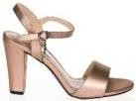 | PENCZ0316WLA107 | Woman Shoe Sandal Gun Metal |  |  | 1 |  |  |  |  | 1 | 69,90 € | 69,90 €
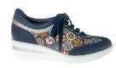 | PENDE0731WBCM14 | Woman Sport Shoe Ptd Calf PU/ Calf PU Multi/Navy |  |  | 1 |  |  |  |  | 1 | 64,90 € | 64,90 €
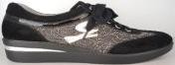 | PENDE0731WEM000 | Woman Sport Shoe Lace/Microfiber Black |  | 8 | 7 | 6 | 7 | 2 |  | 30 | 64,90 € | 1.947,00 €
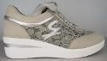 | PENDE0731WEM100 | Woman Sport Shoe Lace/Microfiber Grey |  |  |  |  |  | 1 |  | 1 | 64,90 € | 64,90 €
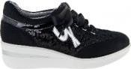 | PENDE0731WGM000 | Woman Sport Shoe Glitter/Metallic Black |  | 2 | 4 | 9 | 6 | 3 |  | 24 | 64,90 € | 1.557,60 €
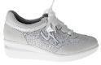 | PENDE0731WGM800 | Woman Sport Shoe Glitter/Metallic White |  |  |  | 1 |  |  |  | 1 | 64,90 € | 64,90 €
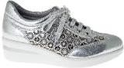 | PENDE0731WLA902 | Woman Sport Shoe Metallic PU Silver |  | 3 | 10 | 11 | 11 | 11 | 2 | 48 | 64,90 € | 3.115,20 €
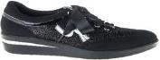 | PENDE0731WTM000 | Woman Sport Shoe Fabric/Microfiber Black | 5 | 2 | 7 | 9 | 9 | 8 |  | 40 | 64,90 € | 2.596,00 €

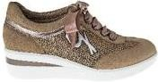 | PENDE0731WTM416 | Woman Sport Shoe Fabric/Microfiber Pink | 4 | 13 | 28 | 30 | 27 | 14 | 5 | 121 | 64,90 € | 7.852,90 €
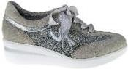 | PENDE0731WTM908 | Woman Sport Shoe Fabric/Microfiber Silver/Light Grey | 1 | 1 | 7 | 7 | 6 | 1 | 1 | 24 | 64,90 € | 1.557,60 €
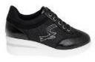 | PENDE0884WGK000 | WOMAN SHOE Black |  | 24 | 13 | 38 | 25 | 19 | 17 | 136 | 69,90 € | 9.506,40 €
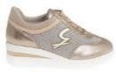 | PENDE0884WGK904 | WOMAN SHOE Light Gold |  | 10 | 27 | 28 | 23 | 11 |  | 99 | 69,90 € | 6.920,10 €
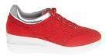 | PENDE0884WRL469 | WOMAN SHOE Suede/Laminated Red/ Silver |  | 9 | 4 | 13 |  | 7 |  | 33 | 69,90 € | 2.306,70 €
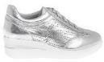 | PENDE0884WRL902 | WOMAN SHOE Suede/Laminated Silver |  | 32 | 70 | 58 | 64 | 28 |  | 252 | 69,90 € | 17.614,80 €
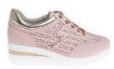 | PENDE0884WRLP74 | WOMAN SHOE Suede/Laminated Pink/ Lt Gold | 1 | 2 | 10 | 9 | 9 | 2 | 2 | 35 | 69,90 € | 2.446,50 €
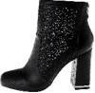 | PENDL0611WCA000 | Woman Ankle Boot Calf PU Black | 1 |  |  |  |  |  |  | 1 | 89,90 € | 89,90 €
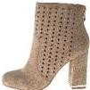 | PENDL0611WMA502 | Woman Ankle Boot Microfiber Beige |  |  | 1 | 1 |  | 1 |  | 3 | 89,90 € | 269,70 €
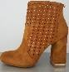 | PENDL0611WMA504 | Woman Ankle Boot Microfiber Leather | 1 |  |  |  |  |  |  | 1 | 89,90 € | 89,90 €
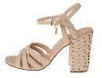 | PENED0639WML530 | Woman Sandal Laminated Microfiber Beige/Lt Gold |  |  | 1 | 2 |  | 1 |  | 4 | 74,90 € | 299,60 €
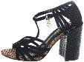 | PENED0640WMC000 | Woman Sandal Microfiber/Calf PU Black |  |  | 1 |  | 1 |  |  | 2 | 74,90 € | 149,80 €
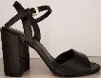 | PENED0641WBA000 | Woman Sandal Printed Calf PU Black |  | 1 | 1 |  |  |  |  | 2 | 69,90 € | 139,80 €
 | PENED0641WBA422 | Woman Sandal Printed Calf PU Rose |  |  | 1 | 1 |  |  |  | 2 | 69,90 € | 139,80 €
 | PENED0641WBA701 | Woman Sandal Printed Calf PU Musk | 2 | 1 |  |  |  |  |  | 3 | 69,90 € | 209,70 €
 | PENGE0343WEA000 | Woman Ballerina Lace Black |  |  |  |  |  | 1 |  | 1 | 45,90 € | 45,90 €

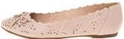 | PENGE0344WCA424 | Woman Ballerina Calf PU Light Rose |  | 4 | 6 | 2 |  | 7 | 4 | 23 | 49,90 € | 1.147,70 €
 | PENGE0593WCA000 | Woman Ballerina Calf PU Black | 8 | 15 | 19 | 10 |  | 8 |  | 60 | 54,90 € | 3.294,00 €
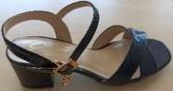 | PENGM0889WAK000 | WOMAN SANDAL Snake PU Black | 16 | 70 | 94 | 110 | 49 | 3 | 2 | 344 | 59,90 € | 20.605,60 €
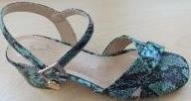 | PENGM0889WAK200 | WOMAN SANDAL Snake PU Blue | 7 | 54 | 64 | 66 | 26 | 3 | 3 | 223 | 59,90 € | 13.357,70 €
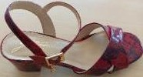 | PENGM0889WAK400 | WOMAN SANDAL Snake PU Red | 7 | 26 | 34 | 16 | 9 | 7 | 4 | 103 | 59,90 € | 6.169,70 €
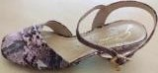 | PENGM0889WAK416 | WOMAN SANDAL Snake PU Pink | 6 | 20 | 14 | 31 | 5 | 8 | 6 | 90 | 59,90 € | 5.391,00 €
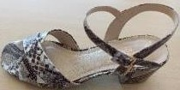 | PENGM0889WAK505 | WOMAN SANDAL Snake PU Sand | 5 | 16 | 16 | 19 | 7 | 5 | 5 | 73 | 59,90 € | 4.372,70 €
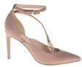 | PENHE0848WCA418 | WOMAN SHOE Calf PU Powder | 1 |  |  | 1 | 2 | 2 |  | 6 | 74,90 € | 449,40 €
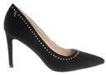 | PENHE0849WMA000 | WOMAN SHOE Microfiber Black |  | 8 | 9 | 2 | 5 | 2 | 2 | 28 | 69,90 € | 1.957,20 €
 | PENHE0849WMA400 | WOMAN SHOE Microfiber Red | 1 | 5 | 6 | 7 | 6 | 2 | 1 | 28 | 69,90 € | 1.957,20 €
 | PENHE0849WMA505 | WOMAN SHOE Microfiber Sand |  |  |  |  | 1 | 1 |  | 2 | 69,90 € | 139,80 €
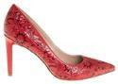 | PENHE0849WPD400 | WOMAN SHOE Patent PU Embossed Red | 1 |  |  |  | 2 | 1 |  | 4 | 69,90 € | 279,60 €
 | PENHE0849WPD505 | WOMAN SHOE Patent PU Embossed Sand |  |  |  | 1 |  |  |  | 1 | 69,90 € | 69,90 €
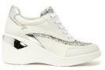 | PENHY1014WCM800 | Hoya Woman Sport Shoe Calf PU/Microfiber White | 23 | 14 | 42 | 29 | 2 | 24 |  | 134 | 79,90 € | 10.706,60 €
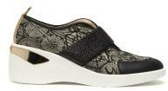 | PENHY1015WVN049 | Hoya Woman Sport Shoe Calf PU/Fabric Theodosia Black/Grey Black | 12 | 15 | 29 | 40 | 6 | 19 |  | 121 | 79,90 € | 9.667,90 €
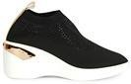 | PENHY1016WSK048 | Hoya Woman Sport Shoe Stretch Knit Black/Lt Gold | 1 | 9 | 8 | 8 | 6 | 5 | 2 | 39 | 89,90 € | 3.506,10 €

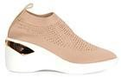 | PENHY1016WSK590 | Hoya Woman Sport Shoe Stretch Knit Nude/Lt Gold | 3 | 8 | 13 | 17 | 11 | 7 |  | 59 | 89,90 € | 5.304,10 €
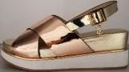 | PENJI0698WLA540 | Woman Sandal Metallic PU Copper/Gold | 1 |  |  |  | 1 | 1 |  | 3 | 69,90 € | 209,70 €
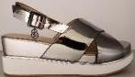 | PENJI0698WLA920 | Woman Sandal Metallic PU Pewter/Silver |  | 2 |  | 1 |  | 2 |  | 5 | 69,90 € | 349,50 €
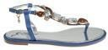 | PENJS0859WOA214 | WOMAN SANDAL Satin Denim |  |  | 2 |  |  |  |  | 2 | 59,90 € | 119,80 €
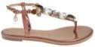 | PENJS0859WOA418 | WOMAN SANDAL Satin Powder | 2 | 6 | 5 | 3 |  | 2 |  | 18 | 59,90 € | 1.078,20 €
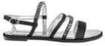 | PENJS0860WOA000 | WOMAN SANDAL Satin Black | 3 | 21 | 39 | 39 | 18 | 11 | 1 | 132 | 59,90 € | 7.906,80 €
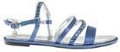 | PENJS0860WOA214 | WOMAN SANDAL Satin Denim | 3 | 11 | 11 | 3 | 2 | 1 |  | 31 | 59,90 € | 1.856,90 €
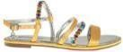 | PENJS0860WOA300 | WOMAN SANDAL Satin Yellow | 3 | 6 | 9 | 3 |  |  |  | 21 | 59,90 € | 1.257,90 €
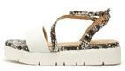 | PENKN1000WKU822 | Kentia Woman Sandal Calf PU/Snake PU White/Multicolor |  | 1 |  | 1 | 1 |  |  | 3 | 69,90 € | 209,70 €
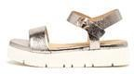 | PENKN1001WLL105 | Kentia Woman Sandal Laminated PU Pewter | 1 |  |  | 2 |  |  |  | 3 | 69,90 € | 209,70 €
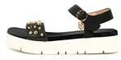 | PENKN1002WCA000 | Kentia Woman Sandal Calf PU Black |  |  |  |  | 2 | 1 |  | 3 | 79,90 € | 239,70 €
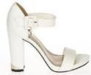 | PENKT0231WCA802 | Woman Sandal Off White |  | 1 |  |  |  |  |  | 1 | 69,90 € | 69,90 €
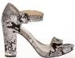 | PENKT0231WCB100 | Woman Sandal Grey |  |  |  | 1 |  |  |  | 1 | 69,90 € | 69,90 €
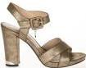 | PENKT0232WCA400 | WOMAN SANDAL Calf PU Red |  |  |  |  |  | 1 |  | 1 | 69,90 € | 69,90 €
 | PENKT0232WLA900 | Woman Sandal Metallic PU Gold |  |  |  | 1 |  |  |  | 1 | 69,90 € | 69,90 €
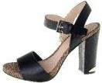 | PENKT0646WCA000 | Woman Sandal Calf PU Black |  |  | 4 |  |  |  |  | 4 | 69,90 € | 279,60 €

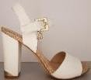 | PENKT0646WCA802 | Woman Sandal Calf PU Off White |  | 2 |  |  |  | 1 |  | 3 | 69,90 € | 209,70 € | 77% | 15,90 € | 47,70 €
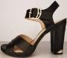 | PENKT0647WBC000 | Woman Sandal Ptd Calf PU/ Calf PU Black |  |  |  | 1 |  |  |  | 1 | 69,90 € | 69,90 € | 77% | 15,90 € | 15,90 €
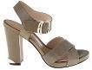 | PENKT0647WBC422 | Woman Sandal Ptd Calf PU/ Calf PU Rose | 2 | 2 | 2 | 2 |  | 1 |  | 9 | 69,90 € | 629,10 € | 77% | 15,90 € | 143,10 €
 | PENKT0647WBC701 | Woman Sandal Ptd Calf PU/ Calf PU Musk | 1 |  |  |  |  |  |  | 1 | 69,90 € | 69,90 € | 77% | 15,90 € | 15,90 €
 | PENKT0862WCA000 | Woman Sandal Calf PU Black |  |  | 1 |  |  |  |  | 1 | 69,90 € | 69,90 € | 77% | 15,90 € | 15,90 €
 | PENKT0862WCA418 | WOMAN SANDAL Calf PU Powder |  | 13 | 10 | 1 | 3 | 4 | 1 | 32 | 69,90 € | 2.236,80 € | 77% | 15,90 € | 508,80 €
 | PENKT0862WMA000 | Woman Sandal Microfiber Black |  |  |  |  | 1 |  |  | 1 | 74,90 € | 74,90 € | 79% | 15,90 € | 15,90 €
 | PENKT0862WPD000 | WOMAN SANDAL Patent PU Embossed Black | 1 | 3 | 7 | 1 | 2 | 3 | 1 | 18 | 69,90 € | 1.258,20 € | 77% | 15,90 € | 286,20 €
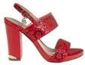 | PENKT0862WPD400 | WOMAN SANDAL Patent PU Embossed Red |  | 19 | 19 | 20 | 17 | 15 | 8 | 98 | 69,90 € | 6.850,20 € | 77% | 15,90 € | 1.558,20 €
 | PENKT0862WPD505 | WOMAN SANDAL Patent PU Embossed Sand |  | 1 | 1 | 1 | 1 |  |  | 4 | 69,90 € | 279,60 € | 77% | 15,90 € | 63,60 €
 | PENKT0863WMA000 | Woman Sandal Microfiber Black | 30 | 66 | 48 | 39 | 9 | 1 | 2 | 195 | 74,90 € | 14.605,50 € | 79% | 15,90 € | 3.100,50 €
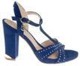 | PENKT0863WMA262 | WOMAN SANDAL Microfiber Deep Blue | 3 | 8 | 14 | 8 |  |  |  | 33 | 74,90 € | 2.471,70 € | 79% | 15,90 € | 524,70 €
 | PENKT0863WMA400 | Woman Sandal Microfiber Red | 32 | 75 | 46 | 53 | 14 |  |  | 220 | 74,90 € | 16.478,00 € | 79% | 15,90 € | 3.498,00 €
 | PENKT0863WMA505 | Woman Sandal Microfiber Sand | 1 | 4 | 4 | 1 | 1 | 1 |  | 12 | 74,90 € | 898,80 € | 79% | 15,90 € | 190,80 €
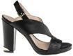 | PENKT0864WCA000 | Woman Sandal Calf PU Black | 1 | 1 | 2 | 3 |  | 2 |  | 9 | 74,90 € | 674,10 € | 79% | 15,90 € | 143,10 €
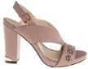 | PENKT0864WCA418 | WOMAN SANDAL Calf PU Powder | 3 | 2 | 3 | 2 | 1 | 1 |  | 12 | 74,90 € | 898,80 € | 79% | 15,90 € | 190,80 €
 | PENKT0864WCA800 | WOMAN SANDAL Calf PU White | 1 | 5 | 2 | 3 | 1 | 4 | 3 | 19 | 74,90 € | 1.423,10 € | 79% | 15,90 € | 302,10 €

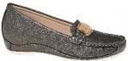 | PENLI0716WBA105 | Woman Shoe Moccasin Printed Calf PU Pewter |  |  |  |  | 1 |  |  | 1 | 49,90 € | 49,90 €
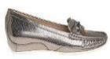 | PENLI0885WAK105 | Woman Shoe Snake PU Pewter |  |  | 3 |  |  |  |  | 3 | 49,90 € | 149,70 €
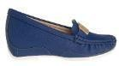 | PENLI0885WSF262 | Woman Shoe Saffiano Deep Blue |  |  |  |  |  | 1 |  | 1 | 49,90 € | 49,90 €
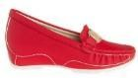 | PENLI0885WSF400 | Woman Shoe Saffiano Red | 4 | 12 | 12 | 18 | 8 | 11 | 2 | 67 | 49,90 € | 3.343,30 €
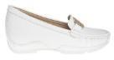 | PENLI0885WSF800 | Woman Shoe Saffiano White | 1 | 10 | 19 | 25 | 12 | 10 | 2 | 79 | 49,90 € | 3.942,10 €
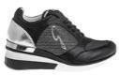 | PENLM0876WCX022 | WOMAN SHOE Calf PU/ Glitter Black/Silver | 1 |  | 4 | 7 | 3 |  | 1 | 16 | 69,90 € | 1.118,40 €
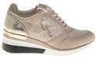 | PENLM0876WCXP70 | WOMAN SHOE Calf PU/ Glitter Lt Gold/Rose |  | 4 |  |  |  | 4 |  | 8 | 69,90 € | 559,20 €
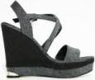 | PENMB0261WGA022 | Woman Shoe Wedge Black/Silver |  | 1 |  |  |  |  |  | 1 | 74,90 € | 74,90 €
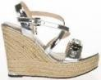 | PENMB0261WLA902 | Woman Shoe Wedge Silver |  |  |  | 1 |  |  |  | 1 | 74,90 € | 74,90 €
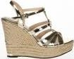 | PENMB0263WLA900 | Woman Shoe Wedge Metallic PU Gold |  | 1 |  |  |  |  |  | 1 | 69,90 € | 69,90 €
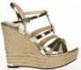 | PENMB0263WLA902 | Woman Shoe Wedge Metallic PU Silver |  |  |  |  |  | 1 |  | 1 | 69,90 € | 69,90 €
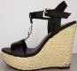 | PENMB0683WCA000 | Woman Shoe Wedge Calf PU Black |  | 1 |  |  | 1 | 1 |  | 3 | 74,90 € | 224,70 €
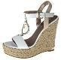 | PENMB0683WCA800 | Woman Shoe Wedge Calf PU White | 1 |  | 2 |  | 1 |  |  | 4 | 74,90 € | 299,60 €
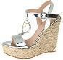 | PENMB0683WLA902 | Woman Shoe Wedge Metallic Silver |  | 1 |  | 2 |  |  | 1 | 4 | 74,90 € | 299,60 €
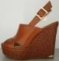 | PENMB0684WCA521 | Woman Shoe Wedge Calf PU Tan |  |  |  | 1 | 1 | 1 |  | 3 | 79,90 € | 239,70 €
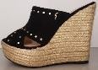 | PENMB0684WMA000 | Woman Shoe Wedge Microfiber Black |  |  |  | 1 |  |  |  | 1 | 74,90 € | 74,90 €

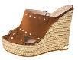 | PENMB0684WMA504 | Woman Shoe Wedge Microfiber Leather |  |  | 1 |  |  |  |  | 1 | 74,90 € | 74,90 €
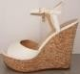 | PENMB0688WBL000 | Woman Shoe Wedge Ptd Calf PU/Metallic Black |  |  |  |  | 3 |  |  | 3 | 69,90 € | 209,70 €
 | PENMB0897WCA000 | Woman Sandal Calf PU Black |  | 1 |  |  |  |  |  | 1 | 99,90 € | 99,90 €
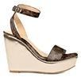 | PENMH1007WTN595 | Mahonia Woman Wedge Shoe Thedosia Print/Lamin.PU Dk Brown/Lt Gold |  |  | 4 | 5 | 3 |  |  | 12 | 79,90 € | 958,80 €
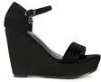 | PENMH1009WMA000 | Mahonia Woman Wedge Shoe Microfiber Black |  | 3 |  | 5 | 3 | 1 |  | 12 | 79,90 € | 958,80 €
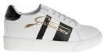 | PENML0881WCA817 | WOMAN SHOE Calf PU White/Black |  | 4 |  |  |  | 4 |  | 8 | 69,90 € | 559,20 €
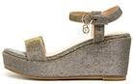 | PENMM1005WTX904 | Malva Woman Wedge Shoe Lurex Light Gold |  | 3 | 3 | 2 | 1 | 1 |  | 10 | 69,90 € | 699,00 €
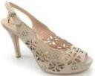 | PENMS0366WNA505 | Woman Shoe Sandal Sand |  |  | 1 |  |  |  |  | 1 | 79,90 € | 79,90 €
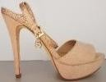 | PENMS0672WMA515 | Woman Sandal Microfiber Nude |  |  |  | 1 |  |  |  | 1 | 74,90 € | 74,90 €
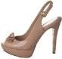 | PENMS0673WPA515 | Woman Sandal Patent PU Nude | 1 |  |  |  |  |  |  | 1 | 74,90 € | 74,90 €
 | PENMS0675WLA902 | Woman Sandal Metallic Silver |  |  |  | 1 |  | 1 |  | 2 | 74,90 € | 149,80 €
 | PENNI0865WCA000 | Woman Sandal Calf PU Black |  |  |  | 1 | 1 | 1 |  | 3 | 74,90 € | 224,70 €
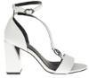 | PENNI0865WCA800 | WOMAN SANDAL Calf PU White |  | 3 | 3 | 3 | 1 | 6 | 1 | 17 | 74,90 € | 1.273,30 €
 | PENNI0867WMA400 | Woman Sandal Microfiber Red | 9 | 21 | 30 | 13 | 9 | 9 |  | 91 | 69,90 € | 6.360,90 €
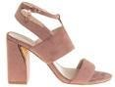 | PENNI0867WMA418 | WOMAN SANDAL Microfiber Powder |  | 5 |  | 8 |  | 7 | 1 | 21 | 69,90 € | 1.467,90 €
 | PENPA0749WCR000 | Woman Flat Sandal Calf PU/Strass Black |  | 1 |  |  |  |  |  | 1 | 54,90 € | 54,90 €
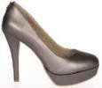 | PENPG0303WLA100 | Woman Shoe Grey | 2 | 20 | 40 | 50 | 45 | 35 | 10 | 202 | 75,90 € | 15.331,80 €
 | PENRI0887WMA418 | WOMAN SANDAL Microfiber Powder |  | 5 |  | 6 | 2 | 5 |  | 18 | 48,40 € | 871,20 €
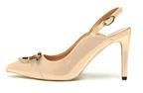 | PENSI0960WPA515 | Scilla Woman Chanel Shoe Patent PU Nude |  |  | 2 |  | 2 | 1 |  | 5 | 79,90 € | 399,50 €

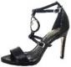 | PENSL0652WCA000 | Woman Sandal Calf PU Black |  |  | 1 |  |  | 1 |  | 2 | 74,90 € | 149,80 €
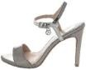 | PENSL0655WLA920 | Woman Sandal Metallic Pewter/Silver |  |  |  |  |  | 1 |  | 1 | 74,90 € | 74,90 €
 | PENSL0655WTC000 | Woman Sandal Fabric/Calf PU Black |  | 1 |  |  |  |  |  | 1 | 74,90 € | 74,90 €
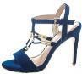 | PENSL0656WMA211 | Woman Sandal Microfiber Dark Blue |  |  |  |  | 1 | 1 |  | 2 | 74,90 € | 149,80 €
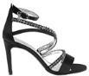 | PENVA0871WOA000 | WOMAN SANDAL Satin Black |  | 2 |  | 1 |  |  |  | 3 | 79,90 € | 239,70 €
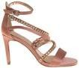 | PENVA0871WOA418 | WOMAN SANDAL Satin Powder |  |  |  | 9 |  |  |  | 9 | 79,90 € | 719,10 €
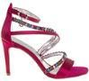 | PENVA0871WOA601 | WOMAN SANDAL Satin Fuchsia |  |  |  |  |  |  | 3 | 3 | 79,90 € | 239,70 €
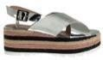 | PENVC0872WLA902 | WOMAN SANDAL Metallic PU Silver |  |  | 1 | 1 |  |  |  | 2 | 69,90 € | 139,80 €
 | PENVC0874WLA904 | WOMAN SANDAL Metallic PU Light Gold | 2 | 7 | 4 |  |  |  | 3 | 16 | 69,90 € | 1.118,40 €
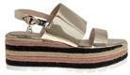 | PENVC0874WLL904 | WOMAN SANDAL Laminated PU Light Gold | 1 |  |  | 1 |  |  |  | 2 | 69,90 € | 139,80 €
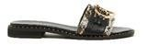 | PENZI0974WKU047 | Zamia Woman Flat Sandal Calf PU/Snake PU Black/Multicolor |  | 1 |  | 2 |  | 1 |  | 4 | 69,90 € | 279,60 €
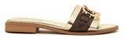 | PENZI0974WTN595 | Zamia Woman Flat Sandal Thedosia Print/Lamin.PU Dk Brown/Lt Gold | 1 | 2 | 2 | 2 |  | 1 | 2 | 10 | 69,90 € | 699,00 €
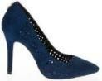 | PENZO0356WMD200 | Woman Shoe Décolleté Lasered Microfiber Blue |  |  |  | 1 |  |  |  | 1 | 59,90 € | 59,90 €
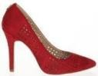 | PENZO0356WMD400 | Woman Shoe Décolleté Lasered Microfiber Red |  | 1 |  | 1 |  |  |  | 2 | 59,90 € | 119,80 €
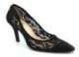 | PENZO0358WEM000 | Woman Shoe Décolleté Black |  | 2 |  | 1 | 2 |  |  | 5 | 64,90 € | 324,50 €
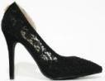 | PENZO0359WEM000 | Woman Shoe Décolleté Black |  | 1 |  | 1 | 1 | 2 |  | 5 | 64,90 € | 324,50 €
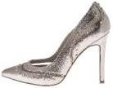 | PENZO0603WLT543 | Woman Shoe Decolletè Laminated Fabric Sand/Blue |  |  |  | 1 |  | 1 |  | 2 | 69,90 € | 139,80 €

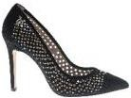 | PENZO0606WMA000 | Woman Shoe Decolletè Microfiber Black |  |  |  |  |  | 1 | 1 | 2 | 54,90 € | 109,80 €
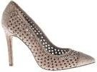 | PENZO0606WMA515 | Woman Shoe Decolletè Microfiber Nude |  |  | 1 |  | 2 |  |  | 3 | 54,90 € | 164,70 €
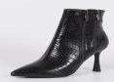 | PINAD1047WAD000 | Aberdeen Woman Ankle Boot Croco Calf PU Black | 3 | 9 | 14 | 14 | 12 | 6 | 1 | 59 | 89,90 € | 5.304,10 €
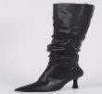 | PINAD1048WCA000 | Aberdeen Woman Boot Calf PU Black | 1 | 5 | 8 | 9 | 9 | 7 | 3 | 42 | 99,90 € | 4.195,80 €
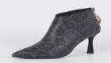 | PINAD1050WUD000 | Aberdeen Woman Ankle Boot Printed PVC Black | 1 | 5 | 1 | 5 | 4 | 4 |  | 20 | 89,90 € | 1.798,00 €
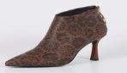 | PINAD1050WUDT25 | Aberdeen Woman Ankle Boot Printed PVC Theodosia Brown |  | 1 | 5 | 2 | 4 | 5 | 3 | 20 | 89,90 € | 1.798,00 €
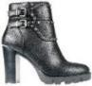 | PINBL0491WCA000 | Woman Ankle Boot Calf PU Black |  |  |  | 1 |  |  |  | 1 | 94,90 € | 94,90 €
 | PINBL0494WCA211 | Woman Shoe Decolletè Calf PU Dark Blue | 2 | 3 | 3 | 3 | 2 | 2 |  | 15 | 79,90 € | 1.198,50 €
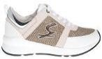 | PINBR0810WCX815 | Woman shoe Calf PU/ Glitter White/Copper | 2 |  |  |  |  |  |  | 2 | 79,90 € | 159,80 €
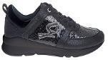 | PINBR0810WGX000 | WOMAN SHOE Black |  | 1 | 1 |  |  |  |  | 2 | 79,90 € | 159,80 €
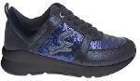 | PINBR0810WGX200 | Woman shoe Blue | 4 | 9 | 9 | 11 | 3 | 2 |  | 38 | 79,90 € | 3.036,20 €
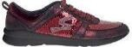 | PINBR0810WGX410 | Woman shoe Bordeaux | 2 | 6 | 24 | 29 | 22 | 24 | 9 | 116 | 79,90 € | 9.268,40 €
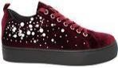 | PINCH0813WTV410 | Woman shoe Velvet Bordeaux |  |  |  |  | 2 |  |  | 2 | 79,90 € | 159,80 €
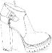 | PINCM0914WCA000 | Carmen Woman Ankle Boot Calf PU Black | 1 | 5 | 14 | 11 | 13 | 7 | 4 | 55 | 79,90 € | 4.394,50 €
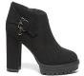 | PINCM0914WMA000 | Carmen Woman Ankle Boot Microfiber Black |  | 15 | 24 | 26 | 13 | 7 | 4 | 89 | 79,90 € | 7.111,10 €
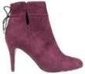 | PINCN0556WMA410 | Woman Anke Boot Microfiber Bordeaux |  | 9 | 12 | 14 | 9 | 11 |  | 55 | 74,90 € | 4.119,50 €

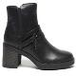 | PINCS0908WCA00A | Chrissy Woman Ankle Boot Calf PU Black | 2 | 5 | 9 | 15 | 9 | 7 | 5 | 52 | 79,90 € | 4.154,80 €
 | PINCS0910WCA000 | Chrissy Woman Boot Calf PU Black | 4 | 3 | 9 | 2 | 5 | 5 |  | 28 | 99,90 € | 2.797,20 €
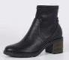 | PINCS1085WBN000 | Chrissy Woman Ankle Boot Tumb.Calf PU/StretchNappa Black |  | 1 | 2 | 2 | 4 | 1 |  | 10 | 79,90 € | 799,00 €
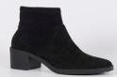 | PINCS1085WSA000 | Chrissy Woman Ankle Boot Suede PU Black | 1 | 2 | 1 | 2 | 2 | 1 |  | 9 | 79,90 € | 719,10 €
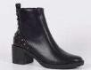 | PINCS1087WCA000 | Chrissy Woman Boot Calf PU Black | 3 | 4 | 6 | 5 | 7 | 5 |  | 30 | 89,90 € | 2.697,00 €
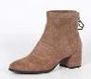 | PINDD1063WSA501 | Dresda Woman Ankle Boot Suede PU Taupe |  |  | 3 | 2 | 3 | 3 | 2 | 13 | 79,90 € | 1.038,70 €
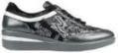 | PINDE0550WCD000 | Woman Sport Shoe Calf PU Embossed/Calf PU Black |  |  |  |  | 1 |  |  | 1 | 64,90 € | 64,90 €
 | PINDE0550WCG000 | Woman Sport Shoe Calf PU/Velvet Paillettes Black | 1 |  |  |  | 1 |  |  | 2 | 64,90 € | 129,80 €
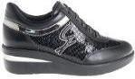 | PINDE0808WCC000 | Woman shoe Calf PU/ Paillettes Black |  | 1 |  |  |  |  |  | 1 | 69,90 € | 69,90 €
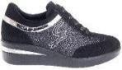 | PINDE0808WMG000 | Woman shoe Microfiber/Glitter Black | 1 |  |  |  |  | 1 |  | 2 | 69,90 € | 139,80 €
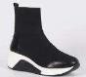 | PINDH1129WTC000 | Delhi Woman Sport Shoes Fabric/Calf PU Black | 1 | 2 |  | 1 | 2 | 1 | 1 | 8 | 89,90 € | 719,20 €
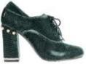 | PINDL0423WTV712 | Woman Ankle Boot Velvet Light Green | 5 | 28 | 44 | 46 | 34 | 24 | 1 | 182 | 74,90 € | 13.631,80 €
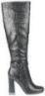 | PINDL0428WCA000 | Woman Long Boot Calf PU Black | 9 | 6 | 7 | 5 | 1 | 1 |  | 29 | ###### | 3.187,10 €
 | PINDL0431WLC105 | Woman Ankle Boot Metallic Calf PU Pewter |  | 1 |  |  |  |  |  | 1 | 84,90 € | 84,90 €
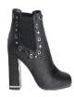 | PINDL0774WCA000 | Woman Ankle Boot Calf PU Black | 3 |  | 3 | 1 | 2 | 2 | 2 | 13 | 89,90 € | 1.168,70 €
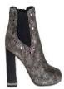 | PINDL0774WLA900 | Woman ankle boot Metallic Gold |  | 9 | 9 | 5 | 7 | 3 | 1 | 34 | 89,90 € | 3.056,60 €
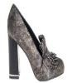 | PINDL0776WLA900 | Woman shoe Metallic Gold | 4 | 13 | 14 | 14 | 6 | 5 | 1 | 57 | 79,90 € | 4.554,30 €

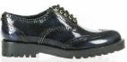 | PINDR0124WAA000 | Woman Shoe Brushed Calf PU Black |  |  |  |  | 1 | 1 |  | 2 | 74,90 € | 149,80 €
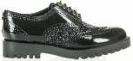 | PINDR0124WAG000 | Woman Shoe Calf PU/Glitter Black |  |  |  |  | 1 | 1 |  | 2 | 74,90 € | 149,80 €
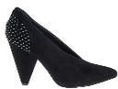 | PINDY0788WMA000 | Woman ankle boot Microfiber Black | 4 | 11 | 22 | 11 | 10 | 11 |  | 69 | 69,90 € | 4.823,10 €
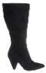 | PINDY0789WMA000 | Woman boot Microfiber Black |  |  |  | 10 |  |  |  | 10 | ###### | 1.049,00 €
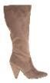 | PINDY0789WMA501 | Woman boot Microfiber Taupe |  | 12 | 19 | 12 | 6 | 5 |  | 54 | ###### | 5.664,60 €
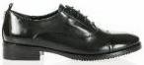 | PINEE0216WCA000 | WOMAN SHOE Calf PU Black | 82 | 344 | 638 | 706 | 585 | 323 | 68 | 2746 | 79,90 € | 219.405,40 €
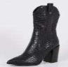 | PINEL1053WAD000 | Elliston Woman Ankle Boot Croco Calf PU Black | 1 | 7 | 8 | 12 | 10 | 4 | 2 | 44 | 99,90 € | 4.395,60 €
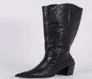 | PINEL1055WAD000 | Elliston Woman Boot Croco Calf PU Black |  | 2 | 1 | 2 |  | 2 |  | 7 | ###### | 769,30 €
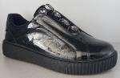 | PINFL1117WLO000 | Flo Woman Sport Shoes Laminated PU/ Calf PU Black |  |  |  |  |  | 1 |  | 1 | 89,90 € | 89,90 €
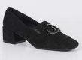 | PINGZ1089WSA000 | Giza Woman Shoes Suede PU Black | 1 | 4 | 4 | 6 | 6 | 3 |  | 24 | 69,90 € | 1.677,60 €
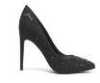 | PINHE0930WMA000 | Heily Woman Pump Microfiber Black |  | 11 | 11 | 13 | 17 | 9 |  | 61 | 69,90 € | 4.263,90 €
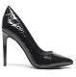 | PINHE0930WPA000 | Heily Woman Pump Patent PU Black |  |  |  |  |  |  | 2 | 2 | 69,90 € | 139,80 €
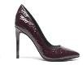 | PINHE0930WPA410 | Heily Woman Pump Patent PU Bordeaux |  | 10 | 19 | 29 | 18 | 14 | 2 | 92 | 69,90 € | 6.430,80 €
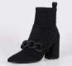 | PINHR1039WSA000 | Harvey Woman Ankle Boot Suede PU Black | 1 | 2 | 2 | 3 | 2 |  |  | 10 | 89,90 € | 899,00 €
 | PINHR1042WSA000 | Harvey Woman Boot Suede PU Black |  | 5 | 7 | 8 | 9 | 6 | 3 | 38 | 99,90 € | 3.796,20 €
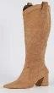 | PINHR1042WSA512 | Harvey Woman Boot Suede PU Camel | 2 | 6 | 12 | 10 | 9 | 5 | 1 | 45 | 99,90 € | 4.495,50 €

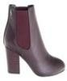 | PINJI0755WCA000 | Woman Ankle Boot Calf PU Black |  | 3 | 2 | 3 | 1 | 2 |  | 11 | 84,90 € | 933,90 €
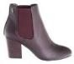 | PINJI0755WCA410 | Woman ankle boot Calf PU Bordeaux | 2 | 3 | 4 | 4 | 4 | 2 |  | 19 | 84,90 € | 1.613,10 €
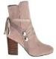 | PINJI0756WMC501 | Woman ankle boot Microfiber/Calf PU Taupe | 3 | 2 | 4 | 6 | 2 | 2 | 1 | 20 | 89,90 € | 1.798,00 €
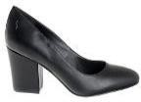 | PINJI0757WCA000 | Woman Ankle Boot Calf PU Black | 10 | 13 | 18 | 7 | 7 |  | 1 | 56 | 74,90 € | 4.194,40 €
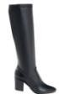 | PINJI0758WCA000 | Woman Ankle Boot Calf PU Black | 2 |  |  |  | 3 |  |  | 5 | ###### | 549,50 €
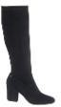 | PINJI0758WMA000 | Woman ankle boot Microfiber Black |  |  | 1 |  |  |  |  | 1 | 99,90 € | 99,90 €
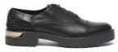 | PINJN0901WCA00A | Jane Woman Shoe Calf PU Black |  | 5 | 6 | 13 | 8 |  | 1 | 33 | 79,90 € | 2.636,70 €
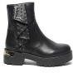 | PINJN0902WCA000 | Jane Woman Ankle Boot Calf PU Black | 2 |  | 1 | 3 |  |  | 1 | 7 | 89,90 € | 629,30 €
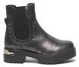 | PINJN0903WLL105 | Jane Woman Ankle Boot Laminated PU Pewter |  |  | 1 | 1 |  |  |  | 2 | 89,90 € | 179,80 €
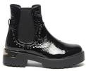 | PINJN0903WPA000 | Jane Woman Ankle Boot Patent PU Black |  |  | 1 |  |  | 1 |  | 2 | 89,90 € | 179,80 €
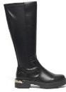 | PINJN0906WCA000 | Jane Woman Boot Calf PU Black |  |  |  |  | 1 | 1 |  | 2 | ###### | 219,80 €
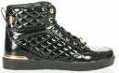 | PINJT0110WCA000 | Woman Sport Shoe Calf PU Black |  |  | 1 | 1 |  |  |  | 2 | 79,90 € | 159,80 €
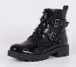 | PINJU1094WNK000 | Juba Woman Ankle Boot Naplak PU Black |  | 1 | 2 | 2 | 1 |  |  | 6 | 99,90 € | 599,40 €
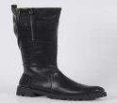 | PINJU1096WCA000 | Juba Woman Boot Calf PU Black |  | 2 |  | 4 | 2 |  |  | 8 | ###### | 879,20 €

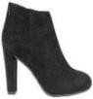 | PINKA0413WMA000 | Woman ankle boot Microfiber Black |  |  | 1 | 1 |  |  |  | 2 | 74,90 € | 149,80 €
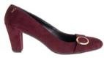 | PINKA0767WMA410 | Woman shoe Microfiber Bordeaux |  | 1 |  | 1 |  |  |  | 2 | 69,90 € | 139,80 €
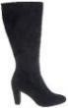 | PINKA0768WMA000 | Woman boot Microfiber Black |  |  |  |  | 1 |  |  | 1 | 99,90 € | 99,90 €
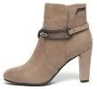 | PINKA0923WMA502 | Karina Woman Ankle Boot Microfiber Beige |  |  |  | 2 | 1 | 1 |  | 4 | 79,90 € | 319,60 €
 | PINKL0543WCD000 | Woman Sport Shoe Calf PU Embossed/Calf PU Black |  |  |  |  |  | 1 |  | 1 | 69,90 € | 69,90 €
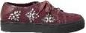 | PINKL0543WMA410 | Woman Sport Shoe Microfiber Bordeaux | 3 |  |  |  |  |  |  | 3 | 69,90 € | 209,70 €
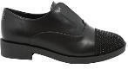 | PINKR0805WCM000 | Woman shoe Calf PU/Microfiber Black |  |  |  |  |  | 2 |  | 2 | 74,90 € | 149,80 €
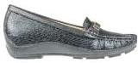 | PINLI0591WLA000 | Woman Shoe Mocassin Metallic Black | 10 | 21 | 32 | 38 | 22 | 16 |  | 139 | 49,90 € | 6.936,10 €
 | PINLI0824WBP000 | WOMAN SHOE Black |  | 1 | 1 |  |  |  |  | 2 | 49,90 € | 99,80 €
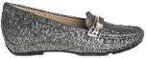 | PINLI0824WSP105 | Woman shoe Pewter |  |  |  |  |  | 1 |  | 1 | 49,90 € | 49,90 €
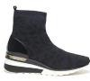 | PINLM0936WSK200 | Alma Woman Sport Shoe Stretch Knit Blue |  |  |  |  |  |  | 2 | 2 | 79,90 € | 159,80 €
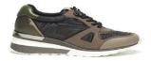 | PINLM0937WYC502 | Alma Woman Sport Shoe Nylon/Calf PU Beige | 1 | 5 | 4 | 6 | 1 |  |  | 17 | 69,90 € | 1.188,30 €
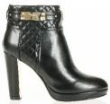 | PINMD0170WCA000 | Woman Ankle Boot Calf PU Black |  |  |  |  | 1 | 1 |  | 2 | ###### | 219,80 €
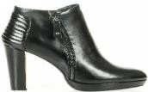 | PINMD0174WCA000 | WOMAN SHOE Calf PU Black |  |  |  |  | 1 | 1 |  | 2 | 84,90 € | 169,80 €
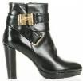 | PINMD0177WCA000 | WOMAN SHOE Calf PU Black |  |  |  |  | 1 | 1 |  | 2 | 89,90 € | 179,80 €

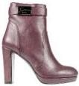 | PINMD0528WCA000 | Woman Ankle Boot Calf PU Black |  |  | 1 |  |  |  |  | 1 | 84,90 € | 84,90 €
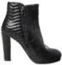 | PINMD0530WCM000 | Woman ankle boot Calf PU/Microfiber Black |  |  |  |  |  | 1 |  | 1 | 89,90 € | 89,90 €
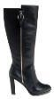 | PINMD0770WCA000 | Woman boot Calf PU Black |  |  |  | 1 |  |  |  | 1 | ###### | 109,90 €
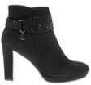 | PINMD0772WMA000 | Woman ankle boot Microfiber Black |  | 1 | 1 |  |  |  |  | 2 | 89,90 € | 179,80 €
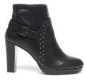 | PINMD0919WCA000 | Mandy Woman Ankle Boot Calf PU Black | 10 | 32 | 56 | 89 | 77 | 57 |  | 321 | 89,90 € | 28.857,90 €
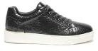 | PINML0938WPA105 | Millie Woman Sport Shoe Patent PU Pewter | 1 | 8 | 10 | 15 | 17 | 11 | 3 | 65 | 69,90 € | 4.543,50 €
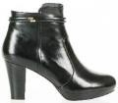 | PINNY0181WCA000 | Woman Ankle Boot Calf PU Black |  |  |  |  | 1 | 1 |  | 2 | 79,90 € | 159,80 €
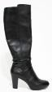 | PINNY0182WCA000 | WOMAN SHOE Calf PU Black |  |  |  | 1 |  |  |  | 1 | 99,90 € | 99,90 €
 | PINOD0782WTV000 | Woman boot Velvet Black | 22 | 34 | 62 | 63 | 28 | 17 | 1 | 227 | 99,90 € | 22.677,30 €
 | PINOD0784WMA410 | Woman ankle boot Microfiber Bordeaux |  |  |  |  | 1 |  |  | 1 | 89,90 € | 89,90 €
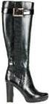 | PINOL0189WCA000 | Woman Long Boot Calf PU Black |  |  |  |  | 1 |  |  | 1 | ###### | 109,90 €
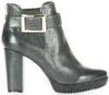 | PINOL0190WCA100 | Woman Ankle Boot Calf PU Grey |  |  |  |  | 1 |  |  | 1 | 79,90 € | 79,90 €
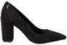 | PINOO0447WBA000 | Woman Shoe Decolletè Printed Calf PU Black |  |  | 1 |  |  |  |  | 1 | 74,90 € | 74,90 €
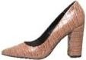 | PINOO0447WBA546 | Woman Shoe Decolletè Printed Calf PU Chestnut | 1 |  |  |  |  |  |  | 1 | 74,90 € | 74,90 €
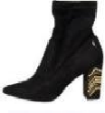 | PINOO0453WMA000 | Woman ankle boot Microfiber Black | 3 | 13 | 23 | 23 | 21 | 17 | 2 | 102 | 79,90 € | 8.149,80 €

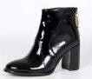 | PINPE1070WPA000 | Petra Woman Ankle Boot Patent PU Black | 2 | 4 | 8 | 7 | 5 | 3 |  | 29 | 79,90 € | 2.317,10 €
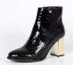 | PINPE1071WAD000 | Petra Woman Ankle Boot Croco Calf PU Black | 1 | 3 | 5 | 1 | 3 | 3 | 1 | 17 | 85,90 € | 1.460,30 €
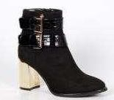 | PINPE1072WES000 | Petra Woman Ankle Boot Suede PU/Croco Calf PU Black | 1 | 3 | 5 | 4 | 4 | 2 |  | 19 | 89,90 € | 1.708,10 €
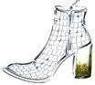 | PINPE1130WAD000 | Petra Woman Ankle Boot Croco Calf PU Black | 2 | 4 | 4 | 5 | 2 | 2 |  | 19 | 85,90 € | 1.632,10 €
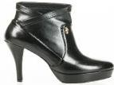 | PINPG0192WCA000 | WOMAN SHOE Calf PU Black |  |  |  |  | 1 | 1 |  | 2 | 84,90 € | 169,80 €
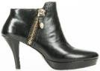 | PINPG0194WCA000 | WOMAN SHOE Calf PU Black |  |  |  |  |  | 1 |  | 1 | 84,90 € | 84,90 €
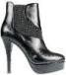 | PINPG0565WCA000 | Woman Anke Boot Calf PU Black | 2 | 6 | 7 | 10 | 5 | 4 |  | 34 | 84,90 € | 2.886,60 €
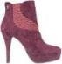 | PINPG0565WMA410 | Woman Anke Boot Microfiber Bordeaux | 10 | 27 | 46 | 54 | 41 | 27 | 6 | 211 | 84,90 € | 17.913,90 €
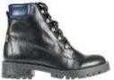 | PINRU0405WCA032 | Woman Ankle Boot Calf PU Black/Deep Blue |  |  |  |  | 1 | 2 |  | 3 | 79,90 € | 239,70 €
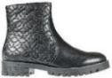 | PINRU0412WCA000 | Woman Ankle Boot Calf PU Black |  | 1 | 1 |  |  |  |  | 2 | 74,90 € | 149,80 €
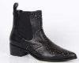 | PINSE1068WCA000 | Essen Woman Ankle Boot Calf PU Black | 1 | 1 |  | 2 | 1 |  |  | 5 | 99,90 € | 499,50 €
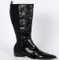 | PINSE1069WLL000 | Essen Woman Boot Laminated PU Black | 4 | 9 | 14 | 15 | 12 | 7 | 1 | 62 | 99,90 € | 6.193,80 €
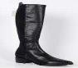 | PINSE1069WLN000 | Essen Woman Boot Calf PU / Lycra Black |  | 1 | 2 | 2 | 2 | 2 |  | 9 | 99,90 € | 899,10 €
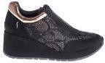 | PINTI0817WMO020 | Woman shoe Microfiber/Lace Black/Gold |  |  | 1 |  |  |  |  | 1 | 79,90 € | 79,90 €
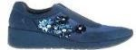 | PINTI0817WMS211 | Woman shoe Microfiber/Satin Dark Blue | 4 | 6 | 7 | 8 | 1 |  |  | 26 | 79,90 € | 2.077,40 €

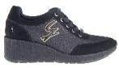 | PINTI0818WMG000 | Woman shoe Microfiber/Glitter Black |  |  |  | 1 |  |  |  | 1 | 79,90 € | 79,90 €
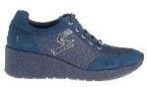 | PINTI0818WMG211 | Woman shoe Microfiber/Glitter Dark Blue | 5 | 11 | 16 | 16 | 13 | 7 | 2 | 70 | 79,90 € | 5.593,00 €
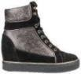 | PINVE0547WBS112 | Woman Mid Sport Shoe Brushed Calf PU Pewter/Black | 1 |  |  |  |  |  |  | 1 | 79,90 € | 79,90 €
 | PINVK0462WCA000 | Woman Long Boot Calf PU Black | 6 | 16 | 23 | 20 | 12 | 7 |  | 84 | ###### | 9.231,60 €
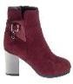 | PINVK0759WMC000 | Woman ankle boot Microfiber/Calf PU Black |  |  | 1 |  |  |  |  | 1 | 84,90 € | 84,90 €
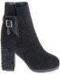 | PINVK0759WMC006 | Woman ankle boot Microfiber/Calf PU Black/strass |  | 2 |  |  |  |  |  | 2 | 84,90 € | 169,80 €
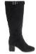 | PINVK0761WMA000 | Woman boot Microfiber Black | 2 | 2 | 2 | 3 | 2 |  |  | 11 | ###### | 1.208,90 €
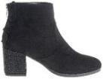 | PINVK0763WMA000 | Woman ankle boot Microfiber Black | 1 | 42 | 122 | 113 | 103 | 36 |  | 417 | 89,90 € | 37.488,30 €
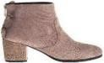 | PINVK0763WMA501 | Woman ankle boot Microfiber Taupe |  | 20 | 38 | 23 | 37 | 21 |  | 139 | 89,90 € | 12.496,10 €
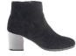 | PINVK0825WMA214 | Woman ankle boot Microfiber Denim | 1 | 33 | 30 | 34 | 46 | 21 | 3 | 168 | ###### | 18.463,20 €
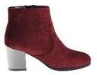 | PINVK0825WMA410 | Woman ankle boot Microfiber Bordeaux |  | 26 | 39 | 30 | 38 |  |  | 133 | ###### | 14.616,70 €
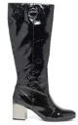 | PINVK0916WPA000 | Vik Woman Boot Patent PU Black |  | 18 | 16 | 25 | 16 | 9 |  | 84 | 99,90 € | 8.391,60 €
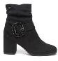 | PINVK0918WMA000 | Vik Woman Ankle Boot Microfiber Black | 2 | 7 | 3 | 3 | 3 | 3 | 1 | 22 | 89,90 € | 1.977,80 €
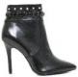 | PINZO0203WCA000 | Woman Ankle Boot Calf PU Black |  |  |  |  | 1 |  |  | 1 | 89,90 € | 89,90 €
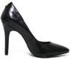 | PINZO0206WCA000 | Woman Shoe Decolleté Calf PU Black |  |  |  |  | 1 |  |  | 1 | 69,90 € | 69,90 €

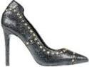 | PINZO0511WCA000 | Woman Shoe Decolletè Calf PU Black |  | 1 |  |  |  |  |  | 1 | 69,90 € | 69,90 €
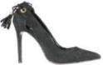 | PINZO0526WMA000 | Woman Shoe Decolletè Microfiber Black |  |  |  | 2 |  |  |  | 2 | 74,90 € | 149,80 €
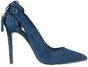 | PINZO0526WMA212 | Woman Shoe Decolletè Microfiber Navy |  |  |  | 1 |  | 1 |  | 2 | 74,90 € | 149,80 €
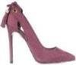 | PINZO0526WMA410 | Woman Shoe Decolletè Microfiber Bordeaux |  |  |  |  |  |  | 1 | 1 | 74,90 € | 74,90 €
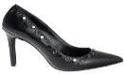 | PINZO0780WCA0SD | Woman shoe Calf PU Black+Studs | 1 |  |  | 1 |  |  |  | 2 | 74,90 € | 149,80 €
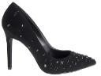 | PINZO0780WMA000 | WOMAN SHOE Microfiber Black |  | 4 | 1 | 3 | 2 |  |  | 10 | 74,90 € | 749,00 €

